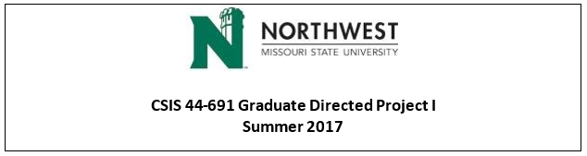

**Team B - CodeGreen - Student Attendance Tracking**

**Client name: Dr. Michael Oudshoorn Instructor: Dr. Michael Oudshoorn**

**Team Logo:**



**Team Members** **and Respective responsibilities**

|  |  |  |  |  |  |
| --- | --- | --- | --- | --- | --- |
| Sl No. | Name | Role | Email | Contact | Responsibilities |
| 1 | Sirisha Vanamali | Primary Contact | S528176@nwmissouri.edu | 816-572-0595 | Responsible for being the first person to contact regarding the project designing the schedules for team meetings and make sure that the team is doing well. |
| 2 | Rohith Babu Sadhu | Client Management | S528171@nwmissouri.edu | 660-528-0926 | Responsible for discussing issues with the client and managing all the responsibilities related to client such as client meetings, client suggestions and so on. |
| 3 | Sri Sai Ram Kumar Mamidala | Data management | S528148@nwmissouri.edu | 704-699-4107 | Responsible for gathering the requirements and make sure if the requirements are deliverable by the due date or not and checking if all the requirements are available as per time and as per requirement. |
| 4 | Vipul Reddy Madadi | Requirements Management | S528144@nwmissouri.edu | 660-528-0357 | Responsible for creating, storing and managing the data and also responsible for designing the database developing the database connectivity. |
| 5 | Vamsi Devalla | Quality and Testing Management | S528117@nwmissouri.edu | 660-541-0439 | Responsible for managing and testing the overall project in every phase to ensure the quality of the solution/ application. |
| 6 | Subba Reddy Pothireddy | Issue Management | S528168@nwmissouri.edu | 660-528-0046 | Responsible for addressing all the issues of the project and getting the relative feedbacks for those issues. |
| 7 | Shankar Rao Vallapurapu | Communications and Documentation management | S528175@nwmissouri.edu | 660-528-0890 | Responsible for creating the documentation of the project at various Stages with a well-defined structure by explaining the purpose and details of each process involved also make sure that communication among the team members is good. Creating group for easy communication in whatsApp and hangouts |

**Screenshot of drive for integrating the project work:**

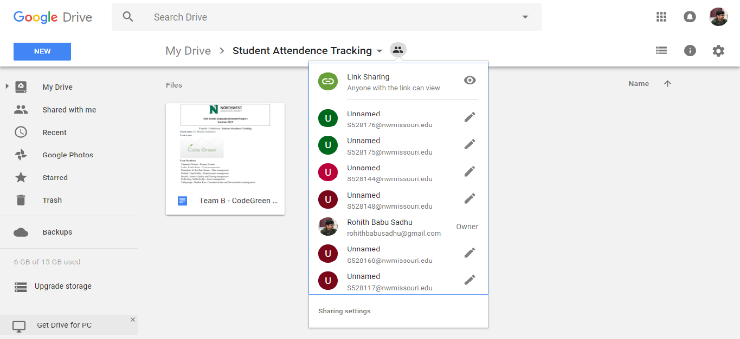

Links for the Repository:

<https://github.com/VamsiDevalla/Student-Attendance-Tracking.git>

**Progress since last week (06/12/2017 to 06/15/2017)**

In the first week we had two meetings with the client for getting the exact requirements for the project and to understand what in specific does the client wanted for the project. The below specified are the notes of the client meetings.

**Client Meetings:**

Client Meeting 1: 13/06/2017

* Client gave us a basic idea of his requirements and ideas about how the authentication should happen.
* Client recommended the QR code approach which involves no hardware.
* Client was particular about a viable solution which would make the user life easy.
* Client was very particular about the abuse of the project.

Client Meeting 2: 06/15/2017

* As a team, we pondered over the authentication problem and came up with three solutions.
* Shared the same content with the client.
* Client asked us to give each solution a thought, discuss pros and cons and zero in on one approach.
* Client suggested us to select a solution that guarantees maximum authentication and will be an easy solution to build.

From the meetings with the client, we agreed on creating an application that captures a QR code which sends all the user information to the database such as Name and SID, the class details and also the IP address of user specifying that the person is present in the class, the instructor can then go ahead and mark/approve the attendance for the specific student. This is the first approach. The second approach is to generate a QR code similar to the first one and instead of capturing of the IP address we plan to capture the GPS location of the person scanning the QR code and thereby checking it with the coordinates of the rooms to check if the person is in the room or not. The third approach is to scan the QR code and after scanning, the student will be asked to type the password which will be given by the instructor. If the student completes the process within 5 min, then he is on time. The last approach is of push notification which is rejected by the Client saying that this may not work for him in all the situations.

The project is as on schedule and we are now at present working with three solutions. Once the solution gets finalized, we can gather the necessary tools and prototype it.

We have identified different tools required for the development of the project such as Github for creating the repository and many google tools such as google docs and hangouts for collaborating our project and for teamwork, Trello for knowing the task assigned for each and every person and the due dates for each of the task.

**Accomplishments by the end of week (06/12/2017 to 06/15/2017):**

* Knowing the strengths and weakness of every individual in the team.
* Deciding on the roles and responsibilities of each and every one in the team.
* Client requirements.
* Creating Github repository.
* Creating trello dashboard for the team.
* Creating a folder in the Google docs for the team.

**Plan for the next week (06/19/2017 to 06/22/2017)**

We plan to have a meeting with the Client to discuss more on the pros and cons of each approach and finally suggest him the approach we zeroed in on. We will pick the platform and tools that we will require to develop this solution. Also, we will decide on whether the solution should be an Android application or IOS application or both. Further, we plan to create a Gantt Chart for our project to get a detailed idea of total days required for the project and the project dependencies. We will be conducting stand-up meetings all through this week to see every person in the team is being accountable.